SPORTS REPORT 2017-2018
ODD SEMESTER
VTU INTERCOLLIGATE GAMES PARTICIPATION AND HOSTED BY KIT
SLNO | GAME | VENUE | DATE | REMARKS
01 | Table Tennis(M) | AIT Chickmangalore | 28th and 29th August 2017 | Semi-Finals
02 | Badminton (M&W)  Central Karnataka Zone | KIT, Tiptur | 04th and 05th September 25017 | Women Semi-Finals Reached
03 | Tennis | VVIT, Mysore | 10th and 11th September 2017 | Quarter Finals
04 | Wt_Pwr_Lifting | SIT, Tumkur | 15th and 17th September | Good Performance
05 | Yoga(M) | RLJIT, Doddabalapura | 20th and 21st September 2017 | Vishnu Prasad Shetty 3rd Sem Mechanical Secured 1st Place Gold Medal
06 | Throw Ball(W) | KIT, Tiptur | 06th and 07th October 2017 | Good Performance
07 | Basket Ball | SIT, Tumkur | 09th and 10th October 2017 | Good Performance
08 | Athletics(M&W) | VTU, Belgavi | 03rd and 06th November 2017 | Good Performance
09 | Gymnastics& Taekwondo(M) | Vemana IT Bangalore | 09th and 10th November 2017 | Vijeth Laxman shetty 5th Sem Mechanical 3 gold and 1 silver and 1 Bronze
10 | Taekwondo(M) | Vemana IT Bangalore | 09th and 10th November 2017 | Darshan TM 5th CSE Bronze Medal and Nikil Bronze Medal
11 | Cross Country coaching camp | KIT, Tiptur | 20th and 27th October 2017 | ………………

SPORTS REPORT 2017-2018

EVEN SEMESTER
VTU INTERCOLLIGATE GAMES PARTICIPATION AND HOSTED BY KIT
SL NO. | GAME | VENUE | DATE | REMARKS
01 | FOOTBALL (M) | SIT, TUMKUR | 20/2/18 and 21/2/18 | GOOD PERFOMANCE
02 | CRICKET (M) | JNNCE, SHIMOGA | 27/2/18 and 28/2/18 | QUARTER FINALS
03 | VOLLEY BALL (M) | AIT, CHIKMANGALURU | 3/3/18 and 4/3/18 | QUARTER FINALS
04 | VOLLEY BALL (W) | ADITYA ACADEMY OF ARCHITECTURE & DESIGN, BANGALORE | 7/3/18 and 8/3/18 | BANGALORE ZONE WINNERS  &  INTERZONE 4th PLACE
05 | YOGA (M & W) | BMSCE, BANGALORE | 27/3/18 and 28/3/18 | VISHNUPRASAD SHETTY GOT 2nd PLACE
06 | KHO KHO (W) | GAT, BANGALORE | 2/4/18 TO 4/4/18 | BANGALORE ZONE WINNERS  &  INTERZONE RUNNERS
07 | KHO KHO (M) | SIT, TUMKUR  &  SJCIT, CHIKKABALLAPUR | 6/4/18 and 7/4/18  &  9/4/18 and 10/4/18 | CENTRAL KARNATAKA ZONE RUNNERS  &  INTERZONE QUARTER FINALS
08 | BALL BADMINTON (M & W) | BMSIT, BANGALORE &  MCE, HASSAN | 13/04/18 and 14/04/18  &  16/04/18 and 17/04/18 | WOMEN’S TEAM BANGALORE ZONE WINNERS&  INTERZONE QUARTER FINALIS.  MENS TEAM SEMI FINALIST IN BANGALORE ZONE & INTER ZONE QUARTER FINALIST
09 | KABADDI (M) | KIT, TIPTUR | 21/04/18 and 22/04/18 | CENTRAL KARNATAKA ZONE SEMI  FINALS
10 | KABADDI (W) | CIT, GUBBI | 05/05/18 TO 08/05/18 | BANGALORE ZONE 4th PLACE & INTER ZONE SEMI FINALS

VARIOUS SPORTS EVENTS INAGURATION PHOTOS ORGANIZED BY THE DEPARTMENT OF PHYSICAL EDUCATION, KIT 2017-18
- VTU Inter Collegiate Central Karnataka Zone Kabaddi Tournament (MEN) on 21st & 22nd of April 2017-18. In this Tournament the Chief Guest was MR. THYAGARAJ, Farmer International Kabaddi Player.

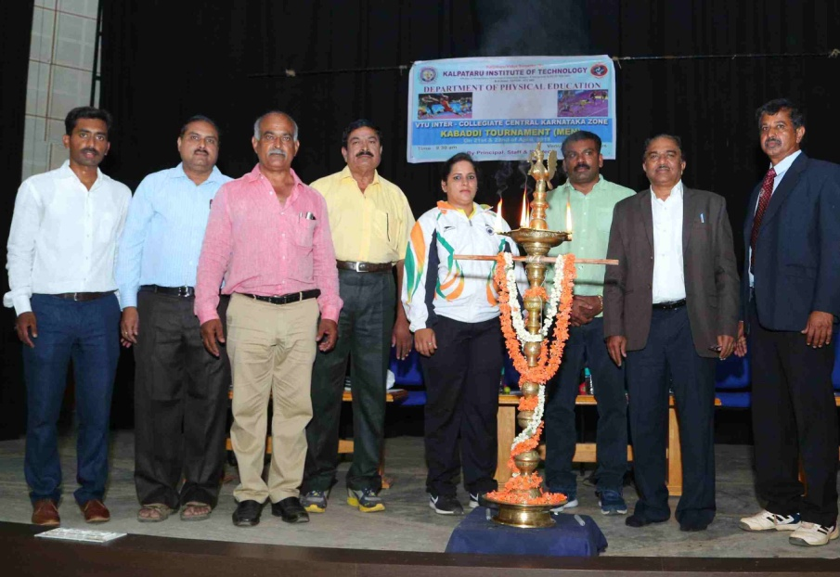
- VTU Inter Collegiate Central Karnataka Zone Throwball Tournament (WOMEN) on 6th & 7th of October 2017-18. In this Tournament the Chief Guests was Ms. AISHWARYA T C, International Throwball Player & MR. SIDDU KARTHIK, National Level Throwball Player.
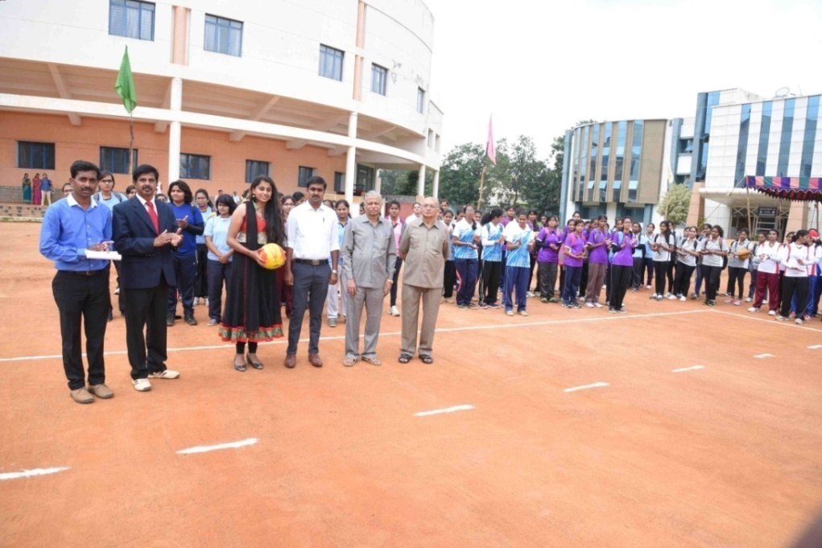
- VTU Inter Collegiate Central Karnataka Zone Badminton Tournament (MEN& WOMEN) on 4th & 5th of September 2017-18. In this Tournament the Chief Guest was MR.RAJESH H, International Badminton Player.
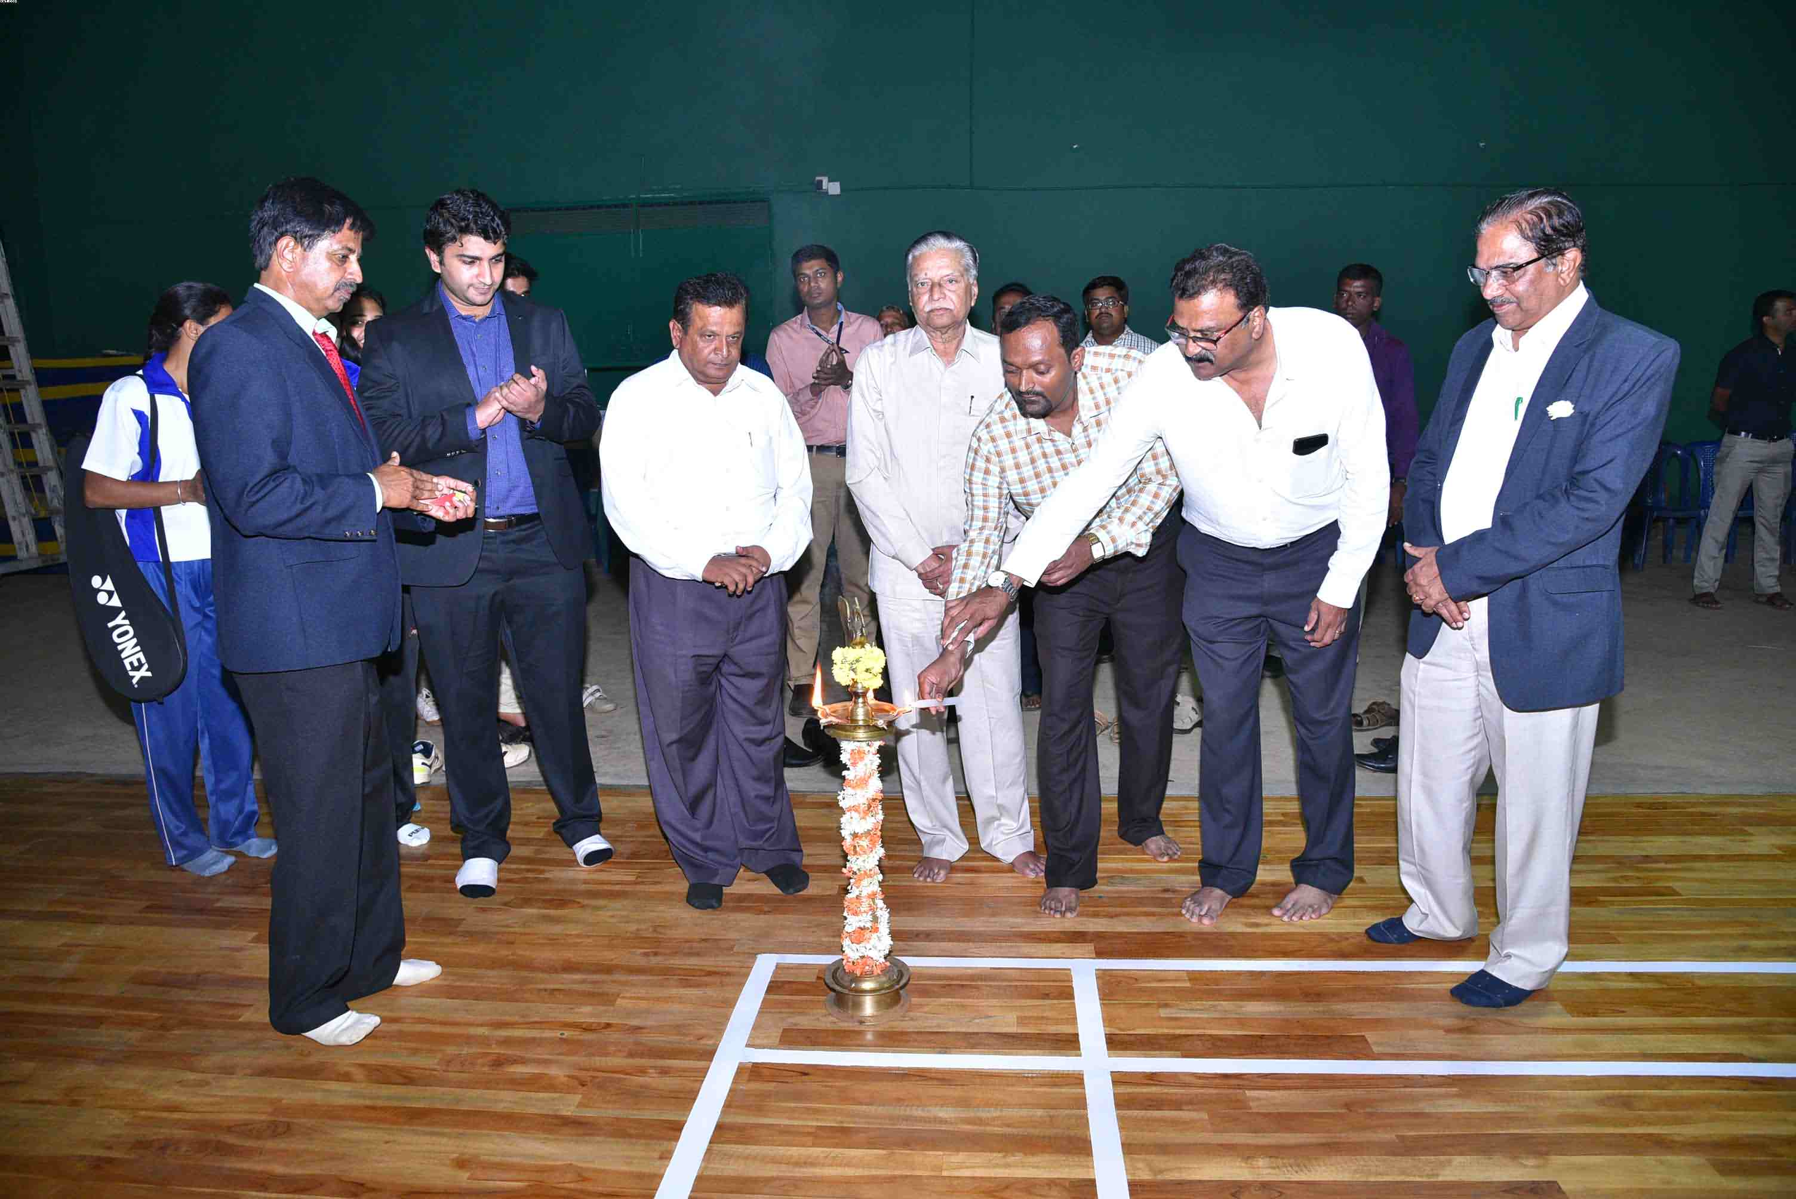

VARIOUS SPORTS ACHIVEMENT PHOTOS OF KIT SPORTS TEAM 2017-18
- VTU INTER COLLEGIATE BANGALORE ZONE Ball Badminton Tournament held at BMSIT, Bangalore on 13th and 14th April 2018.Our team gave high level performance & we are BANGALORE ZONE WINNERS 2017-18.
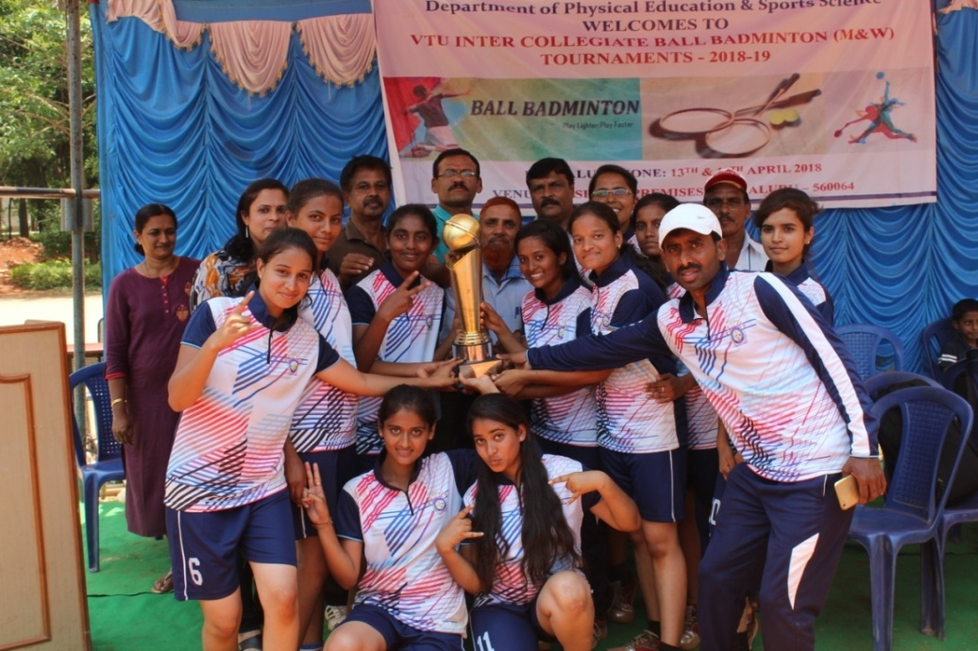

- VTU Inter Collegiate Bangalore Zone VOLLEYBALL Tournament held at AAAT, BANGALORE, on 7th and 8th March 2018.Our team gave good performance & BANGALORE ZONE WINNERS.Bangalore Zone Volleyball Tournament Women Winners in 2017-18.
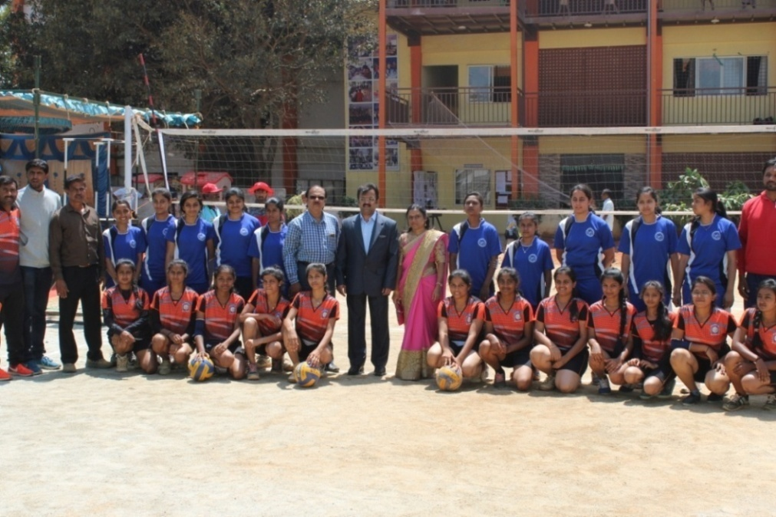

- VTU Inter Collegiate Bangalore Zone KHO KHO Tournament held at GLOBAL ACADEMY OF TECHNALOGY, BANGALORE, on 3rd to 5th April 2018.Our team gave high level performance & BANGALORE ZONE WINNERS. At the same time INTER ZONE RUNNERS in 2017-18.
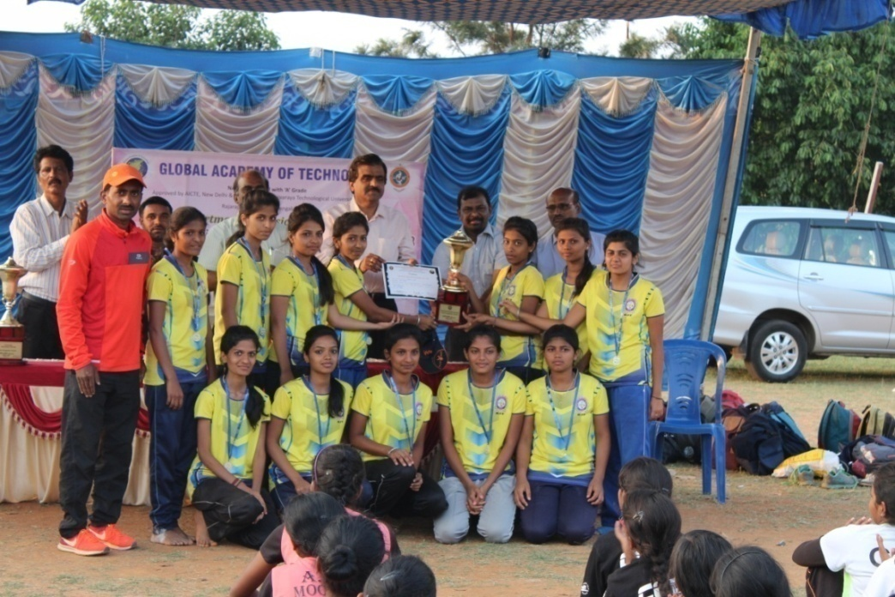

- VTU Inter Central Karnataka Zone KHO KHO Tournament held at SIT, TUMKUR, on 6th and 7th April 2018.Our team gave high level performance & Central Karnataka Zone RUNNERS in 2017-18.
