SPORTS REPORT 2018-2019
ODD SEMESTER
VTU INTERCOLLIGATE GAMES PARTICIPATION AND HOSTED BY KIT
SLNO | GAME | VENUE | DATE | REMARKS
01 | Badminton (M&W)  Central Karnataka Zone | MCE, Hassan. | 27th and 28th August 2018. | Women Reached Semi-Finals.
02 | Table Tennis(M & W) Central Karnataka Zone | KIT, Tiptur. | 03rd and 04th September 2018 | Men Reached Semi-Finals & Women’s Runner Up
03 | TAEKWONDO (M) | VKIT, Bangalore. | 11th & 12th September 2018. | Darshan T M 7th sem/CSE and Nikil Nayaka Both Secured Gold Medals.
04 | Basket Ball (M)  Central Karnataka Zone | PESITM, Shimoga. | 14th and 15th September 2018. | Good Performance
05 | SWIMMING (M & W) | BMSCE, Bangalore. | 3rd October 2018. | Good Performance
06 | Throw Ball(W)  Central Karnataka Zone | BIET, Davanagere. | 09th and 10th October 2018. | Good Performance
07 | WRESTLING & JUDO (M &W) | SAPTAGIRI CE, Bangalore. | 15th to 17th October 2018. | Anusha H V 1st sem/EC Wrestling Women 76kg category secured 2nd place.
08 | Gymnastics (M) | BMSCE, Bangalore. | 23rd and 24th October 2018 | Vijeth Laxman shetty 7th Sem/MEC Secured 2 Gold and 3 Silver Medals & INDIVIDUAL CHAMPIONSHIP
09 | Athletics (M & W) | SJCIT, Chikkaballapur. | 26th to 29th October 2018 | Good Performance

SPORTS REPORT 2018-2019
EVEN SEMESTER
VTU INTERCOLLIGATE GAMES PARTICIPATION AND HOSTED BY KIT
SLNO | GAME | VENUE | DATE | REMARKS
01 | KHO-KHO (M)  Central Karnataka Zone | KIT, Tiptur. | 01st and 2nd March 2019. | CENTRAL KARNATAKA ZONE RUNNERS
02 | CRICKET(M)  Central Karnataka Zone | JNNCE, Shivamogga. | 12th to 14th March 2019 | Good Performance
03 | VOLLEYBALL (M)  Central Karnataka Zone |  | 10th and 11th March 2019 | Good Performance & Reached Quarter-Finals
04 | VOLLEYBALL (W)  B’lore Zone |  | 15th and 16th March 2019. | Good Performance & Reached  Semi-Finals
05 | KABADDI (M)  Central Karnataka Zone | BCE, Sh’b’gola. | 29th and 30th March 2019. | Good Performance & Reached  Semi-Finals

VARIOUS SPORTS EVENTS INAGURATION PHOTOS ORGANIZED BY THE DEPARTMENT OF PHYSICAL EDUCATION, KIT 2018-19
- VTU Inter Collegiate Central Karnataka Zone Kho-Kho Tournament (MEN) on 1st & 2nd of March 2018-19. In this Tournament the Chief Guest was Mr. NAGARAJ H R, Former International Kho-Kho Player.
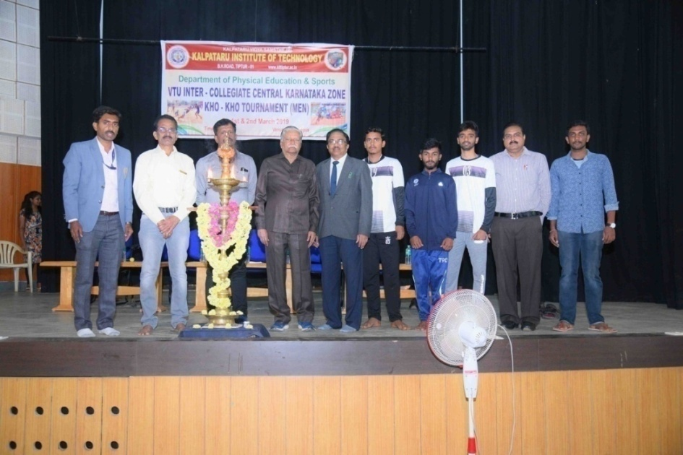

- VTU Inter Collegiate Central Karnataka Zone Table Tennis Tournament (MEN & WOMEN) on 3rd & 4th of September 2018-19.In this Tournament the Chief Guest was Ms. SUHANI L, National Level Table Tennis Player.

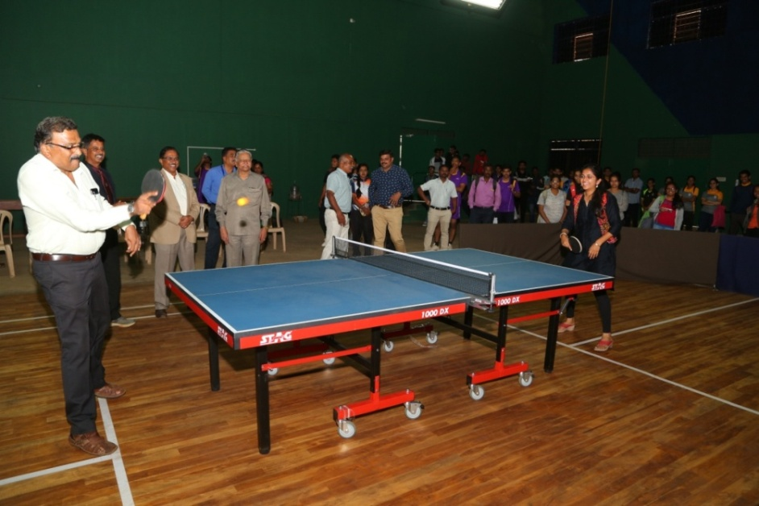

VARIOUS SPORTS ACHIVEMENT PHOTOS OF KIT SPORTS TEAM 2018-19
- VTU Inter Collegiate Central Karnataka Zone Table Tennis Tournament Women Runners-up at KIT on 3rd & 4th September 2018-19.
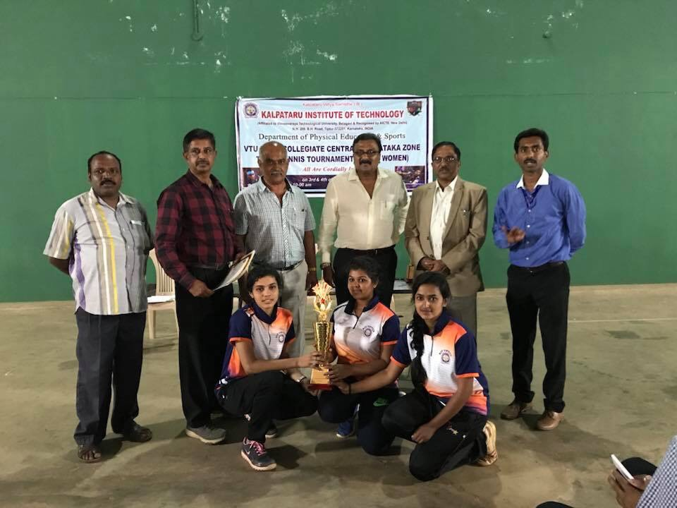

- VTU Inter Collegiate Central Karnataka Zone Kho-Kho Tournament Men Runners-up held at KIT on 1st and 2nd March 2018-19.
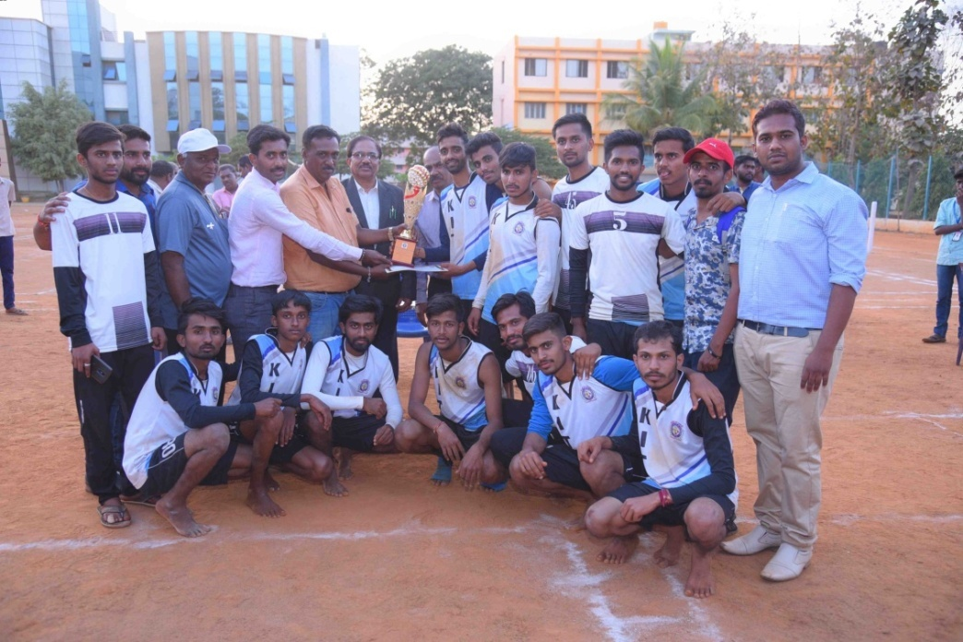
- VTU Inter Collegiate Single Zone Wrestling & Judo (M &W) Tournament held at SAPTAGIRI CE, BANGALORE on 15th to 17th October 2018. Anusha H V 1st sem/ECE Wrestling Women 76kg category secured 2nd place in 2018-19.
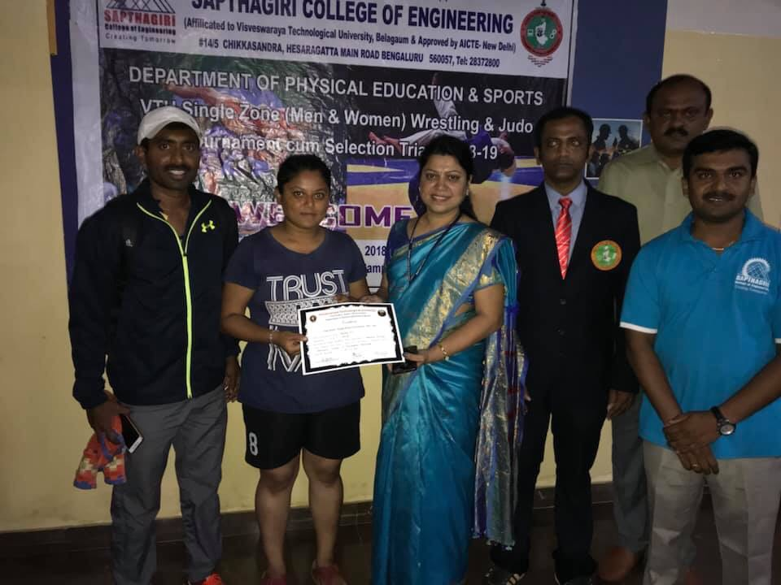

- VTU Inter Collegiate Single Zone GYMNASTIC (M) Tournament held at BMSCE, Bangalore, on 23rd & 24th October 2018. Vijet Laxman Shetty 7thsem/MEC Secured 2 Gold Medals &3 Silver Medals in 2018-19.
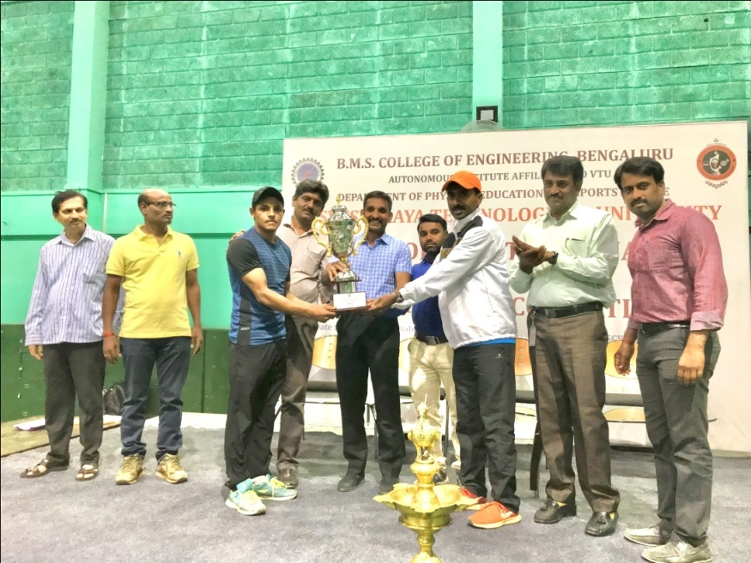
- VTU Inter Collegiate Single Zone Taekwondo (M) Tournament held at VKIT, Bangalore, on 11th & 12th September 2018. Darshan T M 7thsem/CSE (Below 74kg) & Nikhil Nayaka S 7thsem/MEC (Above 87kg) both Secured Gold Medal in Taekwondo 2018-19.
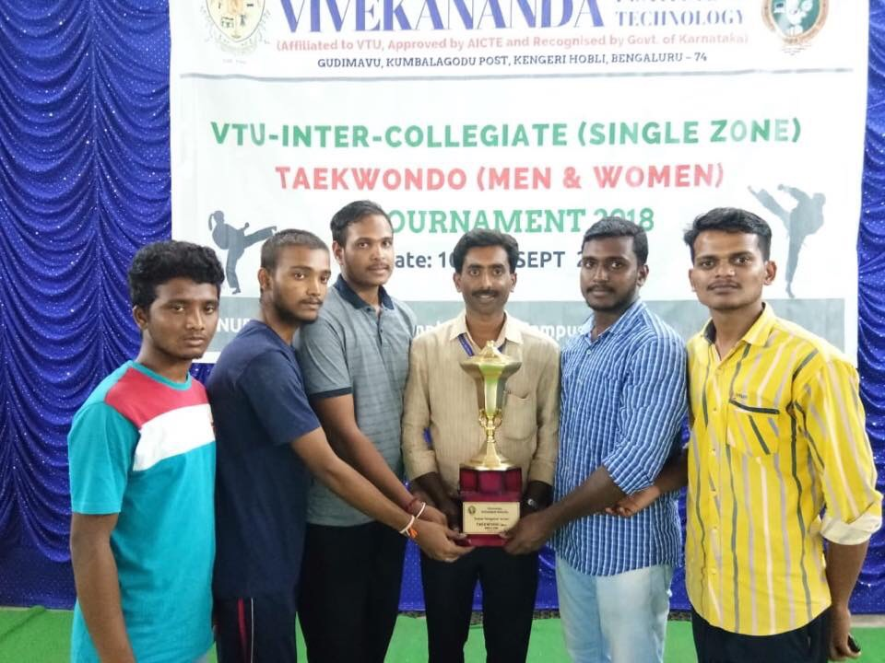
- Jyothi IT Inter Collegiate Throwball Tournament Men Runners-up held at Jyothi IT, Bangalore on 10th October 2018-19.
