SPORTS REPORT 2021-2022
ODD SEMESTER
VTU INTERCOLLIGATE GAMES PARTICIPATION AND HOSTED BY KIT
SLNO | GAME | VENUE | DATE | REMARKS
01 | Badminton (M&W)  Central Karnataka Zone | JNNCE, Shivmogga. | 15th and 16th November 2021. | Both Men & Women teams gave a good performance.
02 | Table Tennis(M & W) Central Karnataka Zone | KIT, Tiptur. | 25th & 26th November 2021. | Women Team Runner-Up & Men Team reached Semi-Finals.
03 | Table Tennis(W) Inter Zone | RVCE, B’lore. | 27th & 28th November 2021. | Our team gave a good performance.
04 | Volleyball(M) CK Zone | SIT, Tumkur. | 11th & 12th December 2021. | Our men team reached Quarterfinals.
05 | Kabaddi(M) CK Zone | MCE, Hassan. | 13th & 14th December 2021. | Good Performance
06 | Basket Ball (M) CK Zone | GMIT, Davangere. | 17th and 18th December 2021. | Good Performance
07 | Football(M) CK Zone | BIET, Davangere. | 27th & 28th December 2021. | Good Performance
08 | Taekwondo(M) Single Zone | Jyothi IT, Bangalore | 28th February 2022. | Darshan G S 3rd sem CIVIL, Selected to All India Inter University Taekwondo Competition held at University of Kerala, Thiruvananthapuram from 21st to 24th March 2022.
09 | Ball Badminton(M) | SJMIT, Chitradurga | 3rd March 2022. | Sujith Kumar T, 1st sem CSE, Selected to South Zone Inter University Ball Badminton Competition held at B S Abdul Rahman Crescent Int. Science & Tech. Chennai, from 10th to 14th March 2022.
10 | Kho-Kho (M & W) | GMIT, Davangere | 8rd March 2022 | Darshan G S 3rd sem CIVIL, Pooja B N 1st sem MBA & Reka B 3rd sem CSE, Selected to South Zone Inter University Kho-Kho(M & W) Competition held at Bangalore North University, Bangalore(M) & Kakathiya University, Warangal (W), from 10th to 14th March & 17th to 20th March 2022.
11 | CHESS (M & W) | SJMIT, Chitradurga | 26th March 2022. | Good Performance

EVEN SEMESTER
VTU INTERCOLLIGATE GAMES PARTICIPATION AND HOSTED BY KIT
SLNO | GAME | VENUE | DATE | REMARKS
01 | THROWBALL (W) CK DIVISION & STATE LEVEL | KIT, Tiptur | 7th to 8th & 9th 10th June 2022 | Our team Winners at CK Division & 2nd Runner Up At State Level.
02 | KHO-KHO (M) | GMIT, Davangere | 17th and 18th June 2022 | Our team gave good performance & REACHED SEMIFINALS.

VARIOUS SPORTS EVENTS INAGURATION PHOTOS ORGANIZED BY THE DEPARTMENT OF PHYSICAL EDUCATION, KIT
- VTU Inter Collegiate Central Karnataka Zone Table Tennis Tournament (Men &Women) on 25th 26th of Nov 2022, in this Tournament the Chief Guest was Ms. KUSHI VISHWANATH International Table Tennis Player, Bangalore.

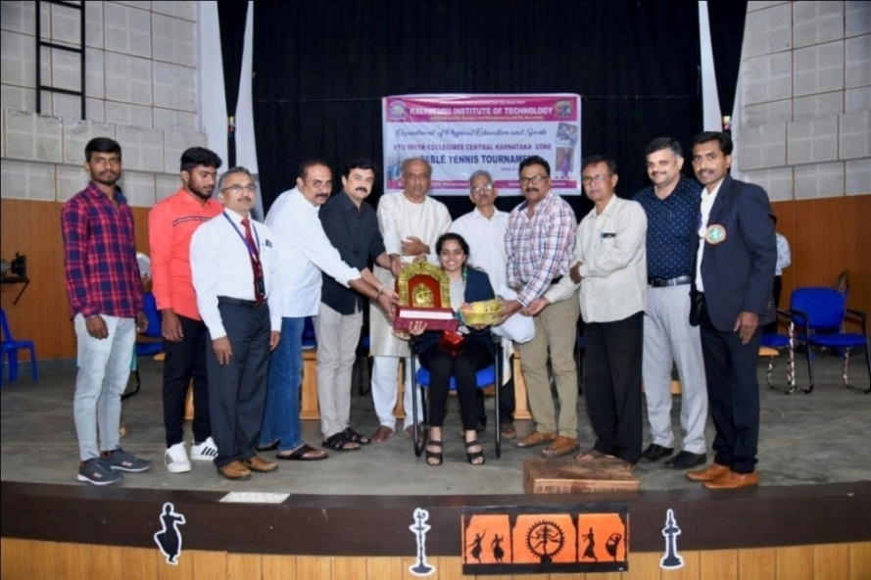
- VTU Inter Collegiate Central Karnataka Division Throwball Tournament (Women) on 7th & 8th of June 2022, in this Tournament the Chief Guest was Ms. Aishwarya K International Throwball Player, Bangalore.
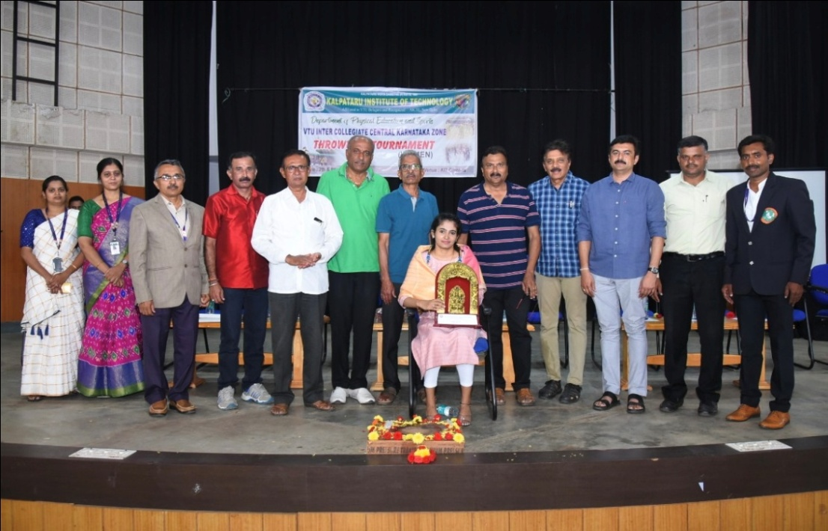

- VTU Inter Collegiate State Level Throwball Tournament (Women) on 9th & 10th of June 2022, in this Tournament the Chief Guest was Ms. Joyce Wesley International Throwball Player, Bangalore.
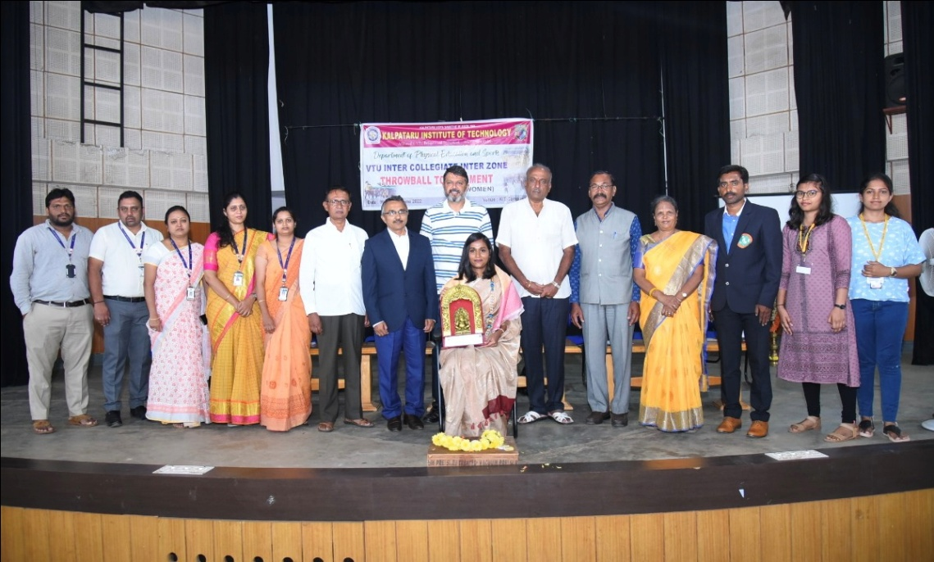

VARIOUS SPORTS ACHIVEMENT PHOTOS OF KIT SPORTS TEAM 2021-22

- VTU Inter Collegiate Central Karnataka Zone Table Tennis Tournament Women Team Runner-Up at KIT on 25th & 26th November 2021.

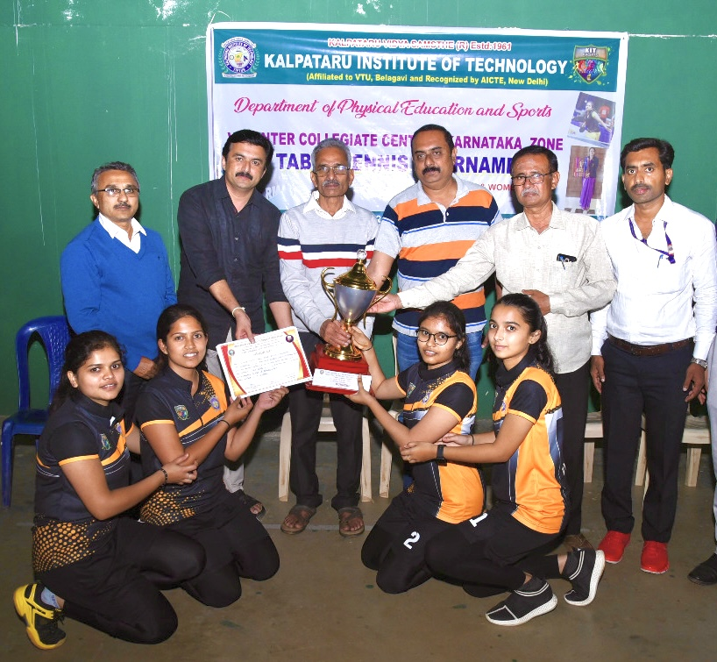

- VTU Inter Collegiate Central Karnataka Division Throwball Tournament Women Team Winners at KIT, Tiptur on 07th & 08th June 2022.
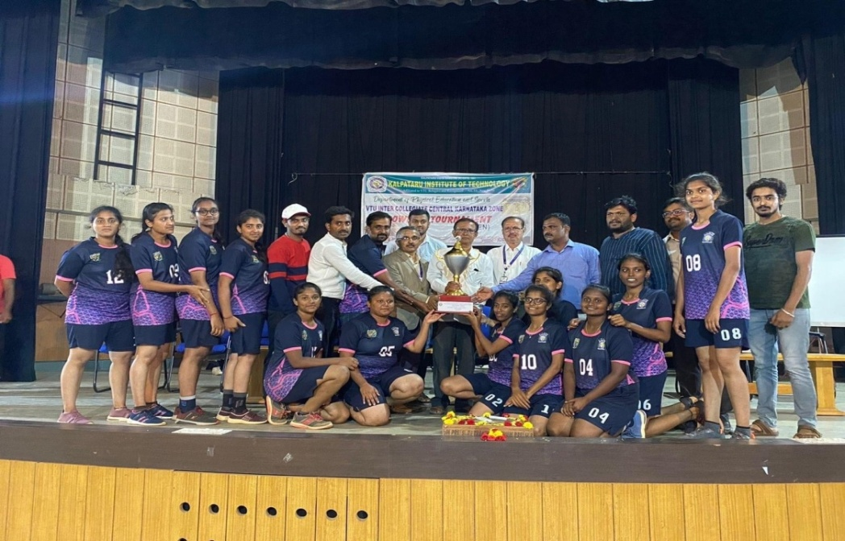

- VTU Inter Collegiate State Level Throwball Tournament Women Team 2nd Runner-Up at KIT, Tiptur on 09th & 10th June 2022.
